Witnessing Workshop Weekend
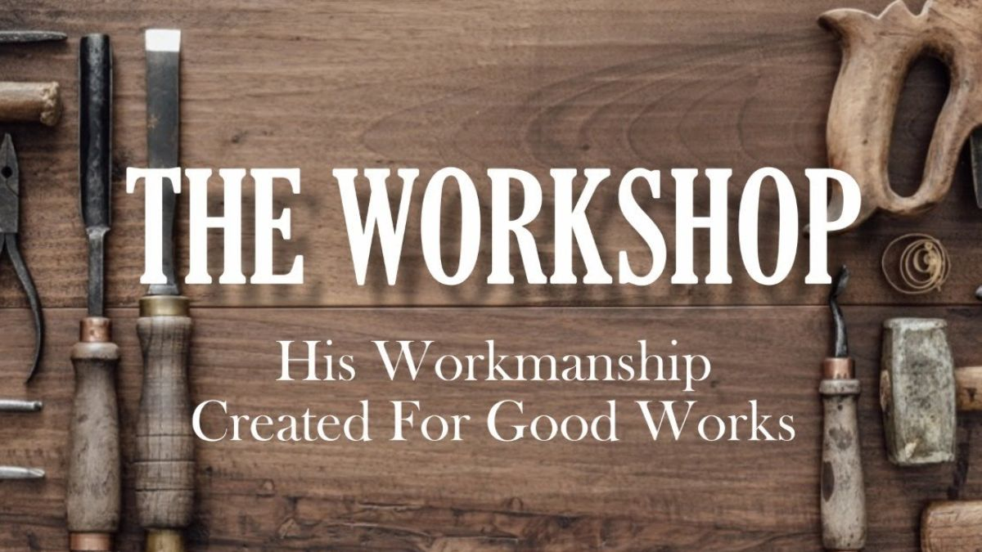

Saturday and Sunday, September 3rd and 4th

Torch Community Church is hosting Evangelism Training. You can learn to share your faith without fear. You keep thinking you should get more serious about evangelism. This training is your opportunity to do something about it!

SATURDAY
9:00 Beginning in the Beginning (Tony R)
10:00 Break
10:15 God-Centered Evangelism (BJ)
11:15 Break
11:30 How to Use the Law (Speaker TBD)
12:30 Lunch at Torch
1:30 Q&A / Role Playing (BJ and Tony R)
2:30 Organize into groups with maps to
distribute gospel invitations
3:00 Go door to door
5:30 Meet back at Torch for pizza and
sharing time.
SUNDAY
9:30 5 Steps to Witnessing part 1 (Tony R)
10:30 Break
11:00 Anointed Evangelism Sermon (BJ)
12:30 Lunch at Torch
1:30 5 Steps to Witnessing part 2 (Tony R)
2:30 Q&A / Role Playing (BJ and Tony R)
3:30 Drive to Cincinnati “Riverfest”
4:00 Meet at Prayer stand. Break out in groups, pray, witness.
6:30 Dinner, fellowship, prayer at local restaurant.

